|  |  |
| --- | --- |
| **ENGLISH** | **TRANSLATION** |
| **HEADLINE** Rate divergence |  |
| **AUTHOR** Mads Koefoed |  |
| **INTRO** The ultimately fruitlesswait for a Federal Reserve rate hike was perhaps the landmark third-quarter macro event, creating a dynamic of policy divergence between the Fed and the easing policies of the Eurozone. Emerging markets, however, also remain a factor as the extreme weakness seen after the late-summer withdrawal of risk appetite may well prove overdone. |  |
| **PULL QUOTE “**We feel that the rapidly building pessimism about China and emerging markets in general is overdone.” |  |
| The impending rate hike from the US Federal Reserve and a third Greek bailout have continued to dominate headlines this year, but the health and performance of emerging markets has also received increased attention following the third-quarter, China-driven correction in risky assets. |  |
| Chinese and US stock indices are both down for the year while European stocks are nearly flat (having previously been up more than 20%). Stocks were not alone in taking a beating, however, as the outlook for emerging-market economies has also been hit hard as the “Chinese hard-landing” camp continues to grow in size and influence |  |
| We have now had below-consensus Chinese growth forecasts for several years, and so the current GDP growth path is arguably validating our view. Nevertheless, we feel that the rapidly building pessimism about China and emerging markets in general is overdone. |  |
| CHART 1 |  |
| **No love for emerging markets** |  |
| Over the last two years, Chinese authorities have steered the world’s second-largest economy in a more market-oriented direction. In the longer term this will doubtlessly provide plenty of benefits, but in the shorter term it is making the economy less manageable. |  |
| This is the main factor behind the commotion in equity markets and the slowdown in economic growth seen over the past few quarters. |  |
| At present, it is doubtful whether China’s official 7% expansion target can be met this year. Credit growth has re-accelerated during the summer months as authorities stepped up their response to the slowdown, and both the housing market and the services sector ate growing robustly. |  |
| Concern about the weak Chinese manufacturing cycle, however, is overshadowing growth in other parts of the economy. Therefore, we may well see an uptick in growth in the final stage of 2015 and into 2016 before growth slows further in line with our forecasts.  CHART 2 |  |
| China is not the only emerging-market economy that is lacking love at the moment. Other prominent emerging economies are struggling, and Brazil and Russia are now in recession. They can point accusatory fingers toward the commodity selloff, but other internal (corruption and a lack of reforms in Brazil) and external (sanctions against Russia) factors are contributing to the overall weakness. |  |
| While we do not expect the selloff in commodities to continue, we also remain unconvinced that any swift rebound in prices is on the cards as the size of the excess supply across the commodity spectrum is simply too great. In addition, serious fiscal challenges loom for Brazil following the country’s Q3 loss of its investment-grade status from S&P. |  |
| The recession is expected to continue into 2016 as both private spending and investment continue to contract. India, meanwhile, should continue to post high growth rates in both Q4 and into next year fuelled by a rebound in sentiment following the last year’s election. |  |
| It is worth noting, however, that we are still waiting for the large-scale reforms that were promised. |  |
| **Central banks playing tug-of-war** |  |
| The Federal Open Market Committee is not far away from its much-awaited rate hike, although September has ultimately proved a disappointment for hawks as elevated risk sweeps across global markets. There is no doubt, however, that the FOMC is getting closer to the first hike in nearly a decade and the December FOMC meeting remains likely though the chance of a no-hike this year has increased.. |  |
| Across the Atlantic, European Central Bank president Mario Draghi is doing all he can to signal that the current quantitative easing scheme may be enhanced in either scope or length. |  |
| These diverging central bank policies are indicative of the present performance of the two economies. The US economy is growing robustly, driven by the re-emergence of the all-important consumer onto the economic scene, a recovering housing market. All of this has come despite strong headwinds from the USD, which has strengthened by close to 20% since mid-2014. |  |
| The currency drag will remain present into 2016 though the effect will fade over the coming quarters as a result of USD Index stabilisation this year. A renewed bout of strength is certainly a possibility, however, as the FOMC starts tightening and if emerging markets weaken further relative to expectations. |  |
| The euro area, on the other hand, is struggling to turn the support from EUR and oil weakness into sustainable growth. The short-term economic outlook looks benign, but further ahead the path looks bumpier as structural reforms have been put on the backburner in most countries. |  |
| Italy and France particularly continue to underwhelm in this regard, which explains our continued sour outlook. Meanwhile, Spain is set to continue as the star performer in 2016 helped by a (slowly) recovering housing market, but the 2015 Spanish election – to be held no later than December 20 – remains a key point of uncertainty for European risk sentiment in Q4. |  |
| CHART 3 |  |
| TABLE 1 |  |

CHART 1:

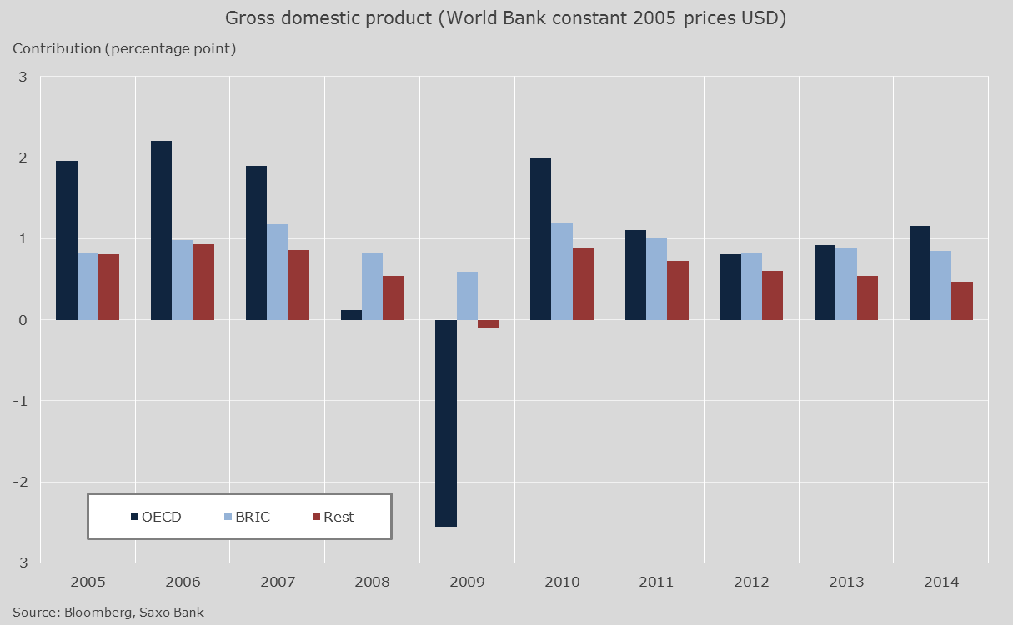

CHART 2:

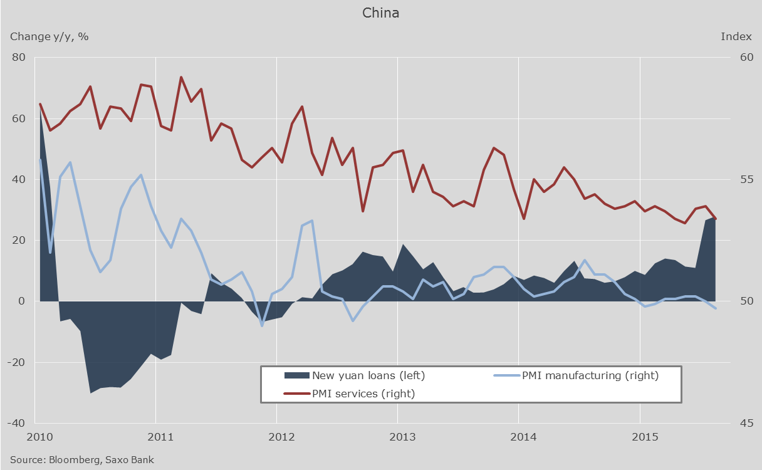

CHART 3:

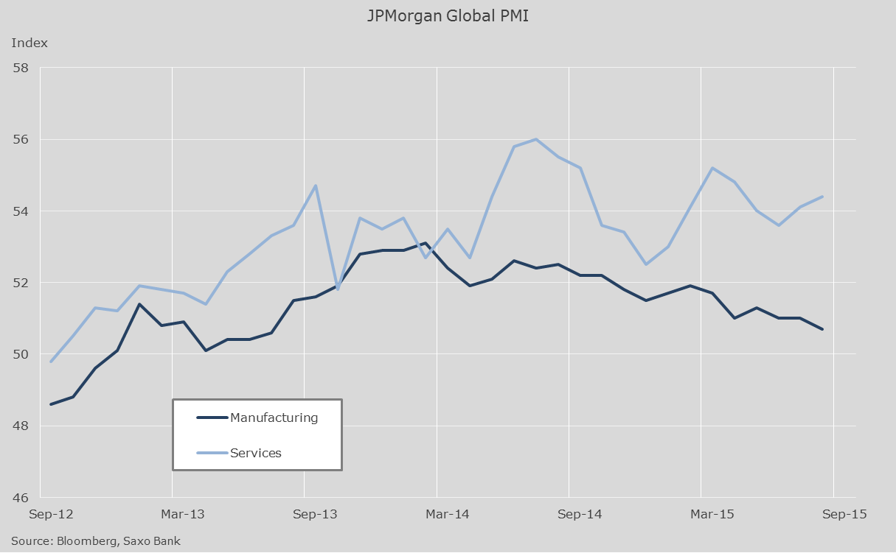

|  |  |  |  |  |  |
| --- | --- | --- | --- | --- | --- |
| **Table 1** | **GDP** | | | **Risks for forecast** | |
|  | ***2014*** | ***2015*** | ***2016*** | ***Upside*** | ***Downside*** |
| World | 2.5 | 2.7 | 2.8 | Lower energy prices and absence of austerity in advanced economies. | Geopolitical tension. Larger-than-expected slowdown in China and other EM economies. |
| United States | 2.4 | 2.6 | 2.8 | Stronger consumer, recovering housing market, and low energy prices. | Stronger US dollar. |
| Euro area | 0.9 | 1.5 | 1.5 | End of austerity, private spending growth, and loose monetary policy. Low energy prices and low euro. | Structural reforms still lacking in some parts of the euro bloc. Geopolitical tensions. |
| United Kingdom | 3.0 | 2.5 | 2.2 | Strong private sector growth. Government policies remain supportive. | Housing sector slows materially. Strong (-er) GBP. |
| China | 7.3 | 6.7 | 6.2 | Some fiscal and monetary easing. | Concerns about credit growth will see authorities refrain from large-scale stimulus. Rebalancing towards consumption will hurt growth. |
| Japan | -0.1 | 0.8 | 1.2 | More monetary and fiscal stimulus may be introduced to arrest the economic slowdown. | Structural reforms still lacking. |
| Notes: GDP (gross domestic product) is inflation-adjusted year-on-year changes in percent. 2014 is actual while 2015 and 2016 are forecasts. | | | | | | |

**#SaxoStrats**

**With China’s efforts to move from an investment-led to a consumer-led model economy hitting choppy water, you could be forgiven for steering clear, but there is plenty of reason to expect China to rise again. Read more in #SaxoStrats here…**https://www.tradingfloor.com/posts/saxostrats-china-on-the-rise-again-6199399

**The current trajectory of the US economy sems to be upwards and that ought to be a boon for home construction. S&P Homebuilders is one that could benefit. Read more in #SaxoStrats here….** https://www.tradingfloor.com/posts/saxostrats-homebuilders-as-proxy-for-stronger-us-economy-6199192